Wk8: Systems Analysis: Data Requirements
here when we get details on how data are inputted and outputted in the organization.
Now you have to understand that the system will deal with the database, takes from and give data to the database. And there is a code that will do that. Why I'm saying that is because it contains two things; the line of code, and the database you are designing as well. The line of code and the database are in your hand, and you can create your own data structure, your own design and interface, all of them are in your hand.
What is not in your hand is the data itself, it is in the hands of user. The user will tell you what they want.
For example, if you are creating a system for user admission in our university. You can choose the programming language, the interface, the design, etc. but the user will tell you the data that you should have, like when the user tells you that when a user comes to the university, we include this part and this part of information about each student, name, email, or other things. And this is the data you are gathering and you will use. Something can be changed but most of the data are coming from the users. Because when you started you don’t know the data, the user or the customer knows.
You have to understand what the data part. You have to understand What type of data comes from the user, what type of data will be stored in the files that will be part of the database, what kind of information it generates, and what is the estimate of the data that will be generated. All of that forms the data requirement.
When you gather requirements, you are collecting data.

Data Requirements
data requirement is a phase that comes after planning. As we said in the previous week, analysis and requirements can be considered as two different phases, or one phase.
Analyst and designer can be different two people, and also can be one person.

- Sometimes in your role as a Systems Designer, you may also be involved in Systems Analysis as part of your Planning and Strategy.

- In some cases, it’s the same individual functioning in these roles.
>>>>>>>>>

Data Requirements
SDLC Methodology

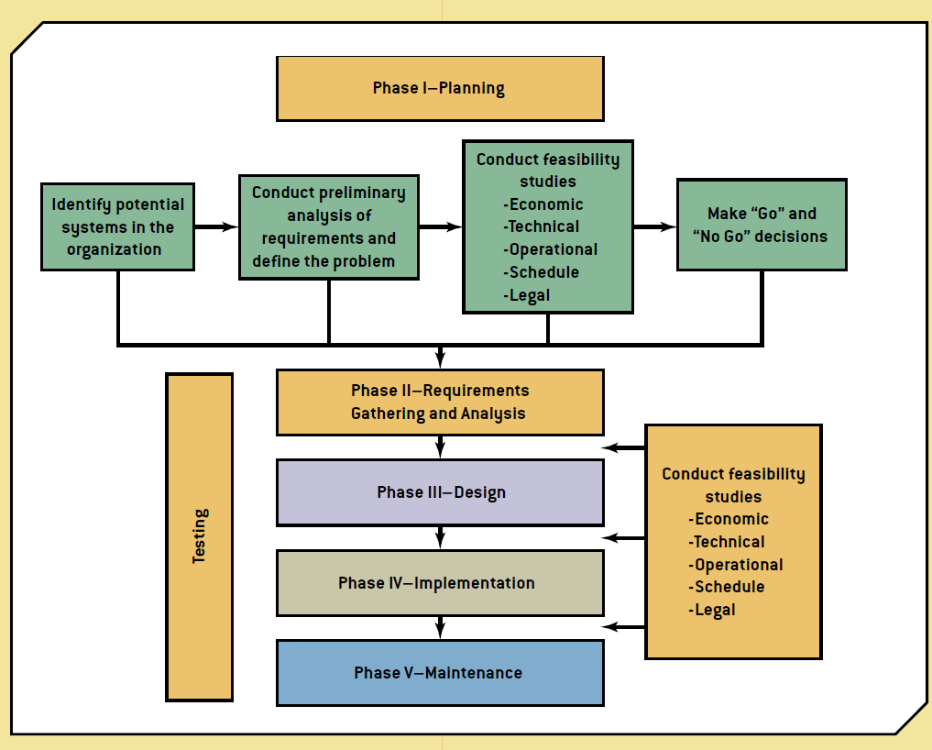

we are in the phase two of the figure. (Phase II- requirements)

>>>>>>>>>>
Data Requirements
- Systems Analysis is part of your requirements gathering.

- In some cases, it’s considered part of your research.
>>>>>>>>

The following two slides are very important slides.
Data Requirements

if you think of organization as a series of processes, each process has steps in it, every process starts from a particular step, that step is executed then the second step, then third then so on until the last step. Once the last step is complete, the process is completed then we go to the next process. Some of the processes can work together, some processes are dependent on other processes to end, some processes depend on other processes to be started, and so on. About 20 years ago, all organization was built on this structured approach.
If you think of the organization as series of processes, as series of steps, that means you are looking at the organization as a form of structure (the first approach).
The advantage of this approach is it is simple to understand.
The disadvantage of SSAD is that SSAD puts special emphasis on the analysis of the system and its documentation. This causes the danger of over-analyzing, which can be very time and cost consuming.
For example, there is a system in the university, there is a process for examination, and there is a process of attendance. So if you look at the system it is easy to understand because the processes are separate, and if we understand each one then the rest is easy.
If we want to create the data for that, we will create a student entity for the first process, and another student entity for the second process, and there will be a redundant because there are two entities of the same thing, and that is because the separation of the processes. It might be the same thing but the processes are different. In structure approach there are lots of traffic but each process is designed for the current need of the system. So they said “let’s build blocks and then put them together to create the system”.
The second approach is object-oriented. They said that instead of making multiple entities of student, for example, make an object (or a class) that can be used with different processes, and once it has been built, just refer to it, instead of writing it again and again. And the class will be used.
In the structured you will understand the process in details. In the OO you see the classes.
Structured is more understandable, and the OO is more efficient.

There are two common approaches utilized in the analysis and design of systems:
- Structured systems analysis and design (SSAD) approach
- Object-oriented approach

>>>>>>>
Data Requirements
There are two common approaches utilized in the analysis and design of systems:
- Involve the use of tools (Unified Modeling Language) for creating analysis models. DFD, ER, Class Diagram and others.
These diagrams are part of the analysis phase, and some can be used in the design phase.
- The models created during the analysis phase become an integral part of the overall design specifications.
We will use the same terminologies and models for the design and development in the project too.

>>>>>>>>

Data Requirements
Examples of tools used can be seen in the table below:

